Equi Travel Safe – Trailer Kit Fitting & Usage Instructions
For a horse on the left-hand side of the trailer when looking from behind

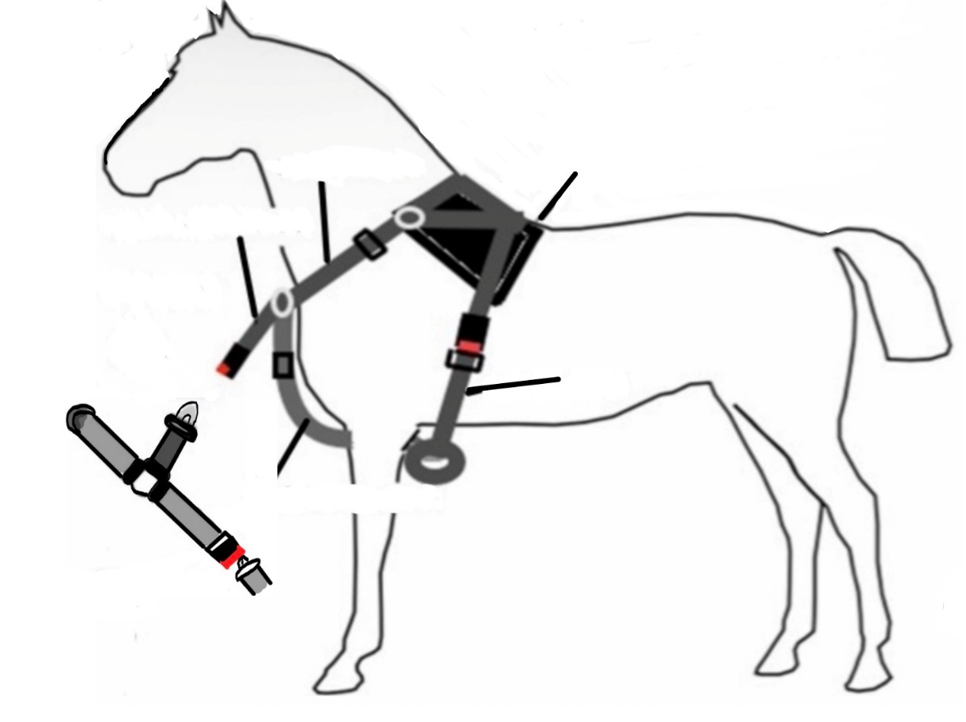

Neck Strap
Back Pad
Harness Clip Strap

To the partition
Girth Straps

Under Chest Strap – between legs

To the wall

Equipment Supplied
Short bolts x 4 (to secure the plate and tie ring to the wall)
Long bolts x 4 (to secure the plate and tie ring to the partition)
Washers x 8 (to be used on the plate side)
4-holed metal plate x 1 (for the partition fixing)
6-holed metal plate x 1 (for the outside wall fixing)
Tie rings x 2 (for the same side of the wall/partition as the horse)
An Equi Travel Safe harness
A trailer fitting strap.

Fitting the Fixing Plates and Rings to your Trailer

Only a professional coach builder or fabricator should be used to fit the fixing plates to your trailer/horsebox, as they will be able to verify that the fixing position in your horsebox/trailer is strong enough to be used in conjunction with the Equi Travel Safe.

IMPORTANT NOTE:
The holes are drilled in the trailer wall, using the six-holed plate as a template, working from the external side of the outside wall to the inside, to ensure the plate sits properly on the outside.

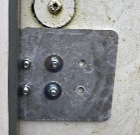
- The fixing plates should be fitted to the outside of the external wall of the trailer and to the partition. The external wall plate (the six-holed one) should be fitted first, as the tie ring and plate holes need to line up at either side of the wall/ partition. (see below for fixing height)
- The tie rings are affixed on the inside of the wall on one side of the horse and the inside of the partition on the other.
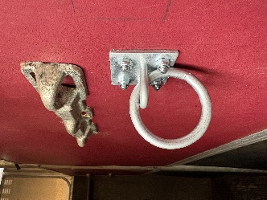
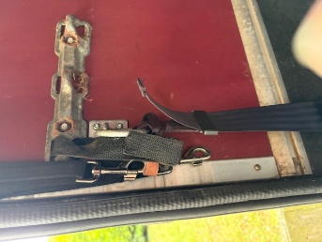

Fixing Height
The plates should be fitted so that when the horse is in the trailer and strapped in, the fixing strap sits horizontally or slightly ‘n’ shaped at no lower than the height of the top of the legs.

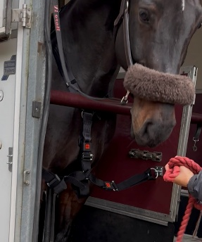

How to attach the ‘Fixing Strap’ to the tie rings

Thread the looped end through the tie ring, then pass the entire fixing through the loop. This is at partition side (Figures 2 & 3). The tongue on the seat belt fixing strap is affixed to the wall in the same way (Figure 4).

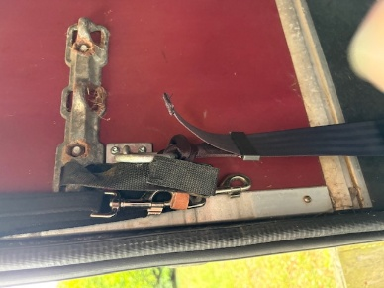
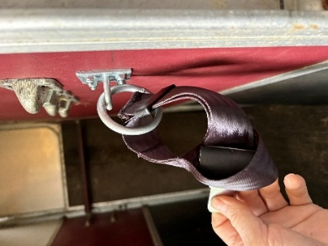
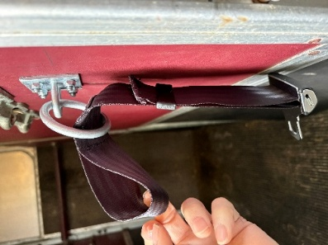

Figure 2 Figure 3 Figure 4

How to fit the Equi Travel Safe to the horse

- Place the Equi Travel Safe harness over the horse’s head and onto its back, webbing side up, ensuring the back pad is over the horse's wither (from the base of the neck). If the horse is concerned about the pad passing over their head, turn it sideways so that just the webbing passes over.
- Pass the longest girth strap around the horse’s ribcage and through the loop at the end of the under-chest strap.
- Fasten the girth straps by pressing the two parts of the buckle together until you hear them click into place. These clip together on the horse's right (offside), or left (nearside), depending on which harness has been purchased.
- Use the adjusters on the neck, girth, and under chest straps to tighten the harness by pulling down on the loose end of the straps until it fits snug. Start with the neck, then the girth and finally the under-chest straps. All straps need to be under tension, but comfortable.
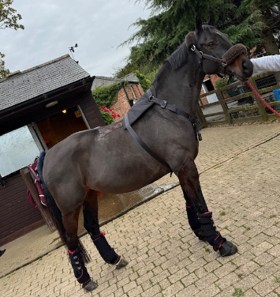
Make sure the harness is snug; if it is too loose, its impact may be compromised. (Consultations are available, info@equitravelsafe.co.uk)
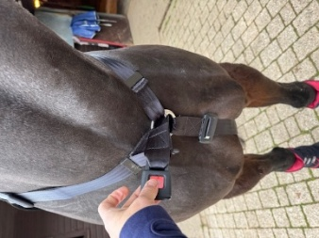

How to attach a harnessed horse to a trailer

- Only once the Equi Travel Safe has been fitted correctly to the horse, and the trailer clip strap is fitted in the correct place, at the correct length, should the horse be loaded into the trailer.
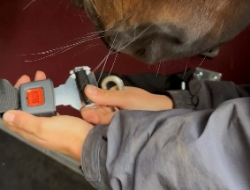
- Load the horse and then affix the trailer fastening to the partition fixing.

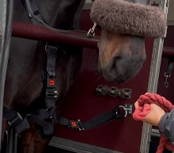
- To attach the horse, push the metal end of the middle fastening on the trailer strap into the receiver attached to the horse until they click together.

Adjust the trailer clip strap to a comfortable length (shouldn’t be necessary after first use). It should be tight enough that it’s not drooping, but not so tight that it restricts balance.

How to Remove the Equi Travel Safe from the trailer, then the horse

- To remove the harness, press the red button on the middle strap first (the one attached to the horse)
- Release the clip from the horse and then from the wall side, gently allowing the trailer fixing to hang down the wall.
- Remove the girth strap from the loop of the under-chest strap before taking the harness off, over the horse's head, again turning it sideways if the horse is concerned about the pad passing over his head.

